## Test Automation approach for online retail store

# Technologies:

* Cucumber-JVM
* Selenium WebDriver with Java bindings
* Java 8
* TestNG

This solution has developed in three distinct projects.

1. test-framework - This project consists of core methods that can be used across any automation project in the organization.
2. shopping-cart-pageobjects - This project consists of classes related to each page of the application, commonly known as Page Objects. It has a dependency on test-framework project to call common methods.
3. shopping-cart-Tests- This project holds test cases related to online shopping store project. It has dependencies on test-framework and shopping-cart-pageobjects.

This structure is beneficial as it allows multiple testers/ teams to work on all three projects independently. In other words, it allows the break down of the work into more manageable pieces. This structure allows testers or business users to add test cases without having expert knowledge on the underlying framework and it is scalable for bigger projects.

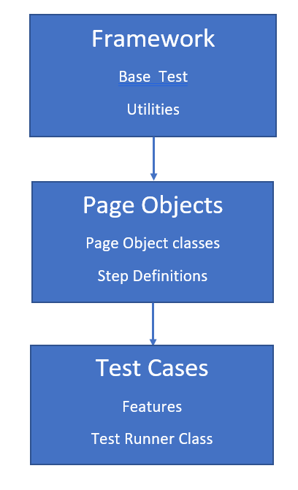

# test-framework

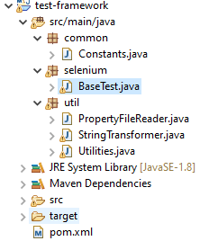

# Shopping-cart-pageobjects

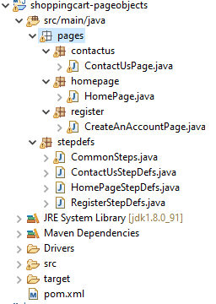

# Shopping-cart-tests

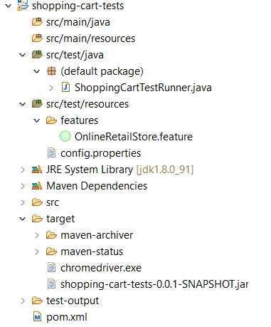

# Test Results

